Group Meeting #1:

# 1. Attendance

* Jesse Griffin
* Patrick Kent
* Pierson Carulli

# 2. Location

* WSUV Library

# 3. Discussion

* Come up with use case diagram for our user
* Define languages used for our project
* Draw out basic design for our 5 pages that will be navigated by user
* Discuss security concerns for project
* Figure out git and git conflicts before end of meeting
* Established workflow to avoid merging conflicts

# 4. Post Meeting Consensus

White board notes:

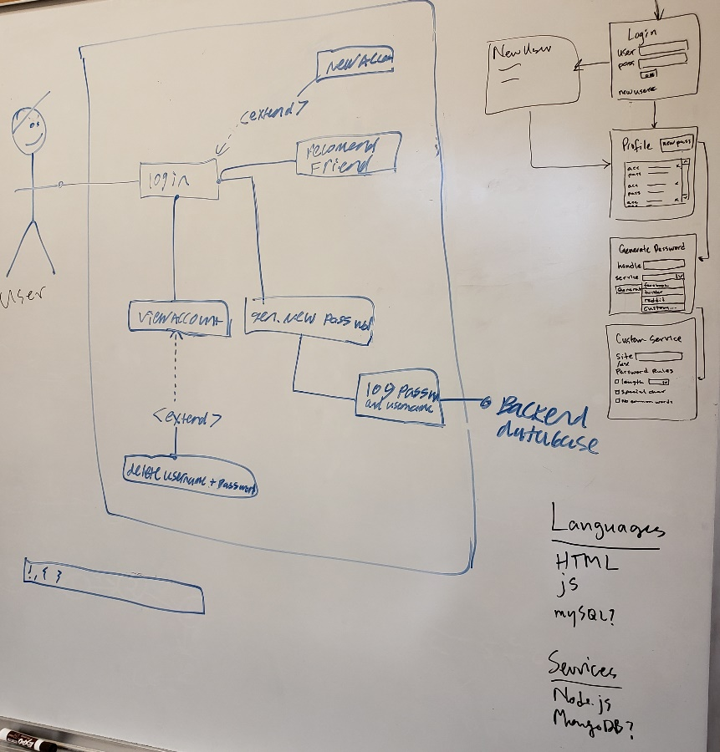

How we broke up SRS:

Jesse – Section 3, Section 4.1

Patrick – Section 1, Section 4.3

Pierson – Section 2, Section 4.2